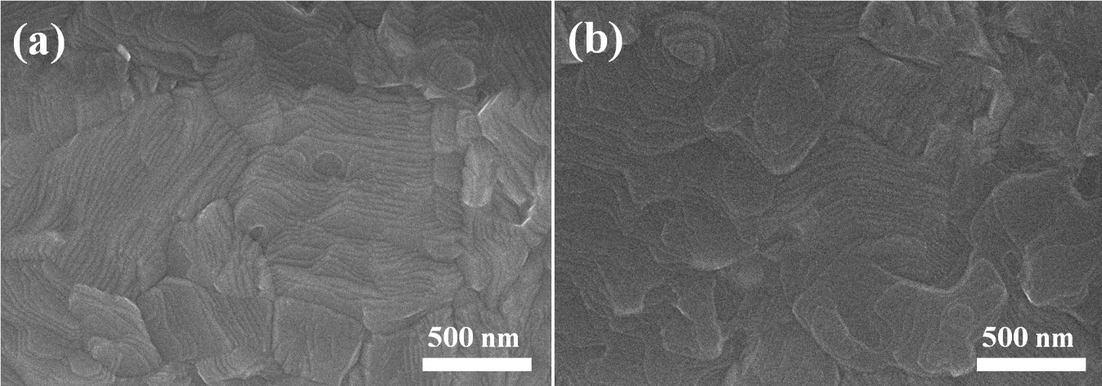
Fig. S1 SEM images of (a) perovskite deposited on the bare TiO₂ and (b) perovskite deposited on the 2% Nb:TiO₂ layer

Fig. S2 Absorbance spectra of perovskite film deposited on bare TiO₂ and 2%Nb:TiO₂ layer

Device | R_{s} (Ω) | R_{ct} (Ω) | R_{rec} (kΩ)
TiO₂ | 27.1 | 216 | 5.23
2% Nb:TiO₂ | 26.2 | 178 | 119
Table S1 Parameters employed for the fitting of the impedance spectra of devices based on the bare TiO₂ and 2%Nb:TiO₂

